Test 2.0
5 Junctions each with Traffic signals
random traffic
simulated for 86400s = 24 hours

Data definitions:
Junctions names A B C ...
edge from A to B is AB
edge from B to A is BA
and so on
12 edges 5 nodes
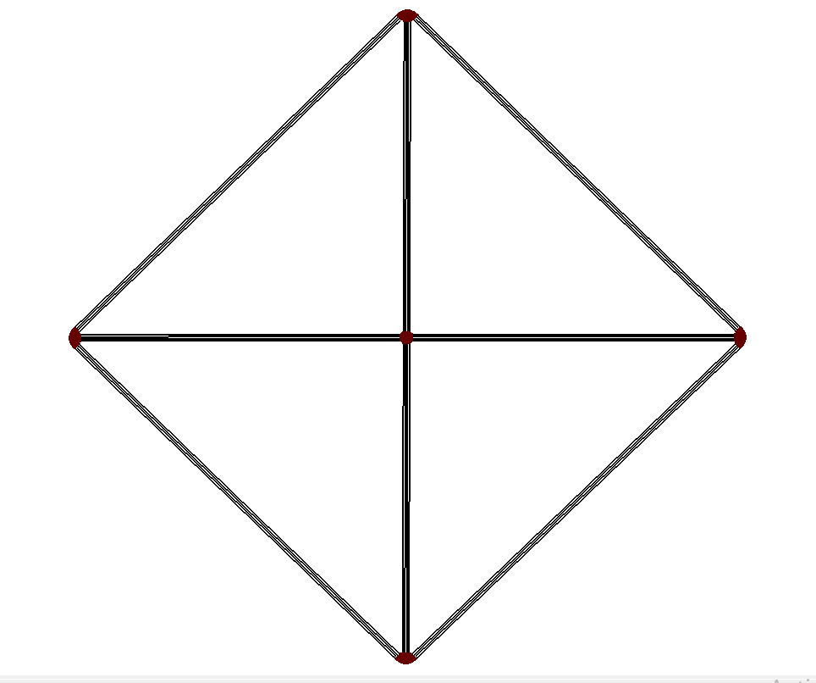
Columns in csv:
Time
A
B
C
D
E
Vehicle Count at Junction A
Vehicle Count at Junction B
Vehicle Count at Junction C
Vehicle Count at Junction D
Vehicle Count at Junction E
Avg Speed on AB
Avg Speed on AC
Avg Speed on AD
Avg Speed on BA
Avg Speed on CA
Avg Speed on CB
Avg Speed on CD
Avg Speed on CE
Avg Speed on DA
Avg Speed on DC
Avg Speed on DE
Avg Speed on EB
Avg Speed on EC
Avg Speed on ED

